Project Design Phase-II
Data Flow Diagram & User Stories

Date | 31 January 2025
Team ID | LTVIP2026TMIDS80646
Project Name | Dog Breed Identification using Transfer Learning (VGG19) with Flask Deployment
Maximum Marks | 4 Marks

Data Flow Diagrams:
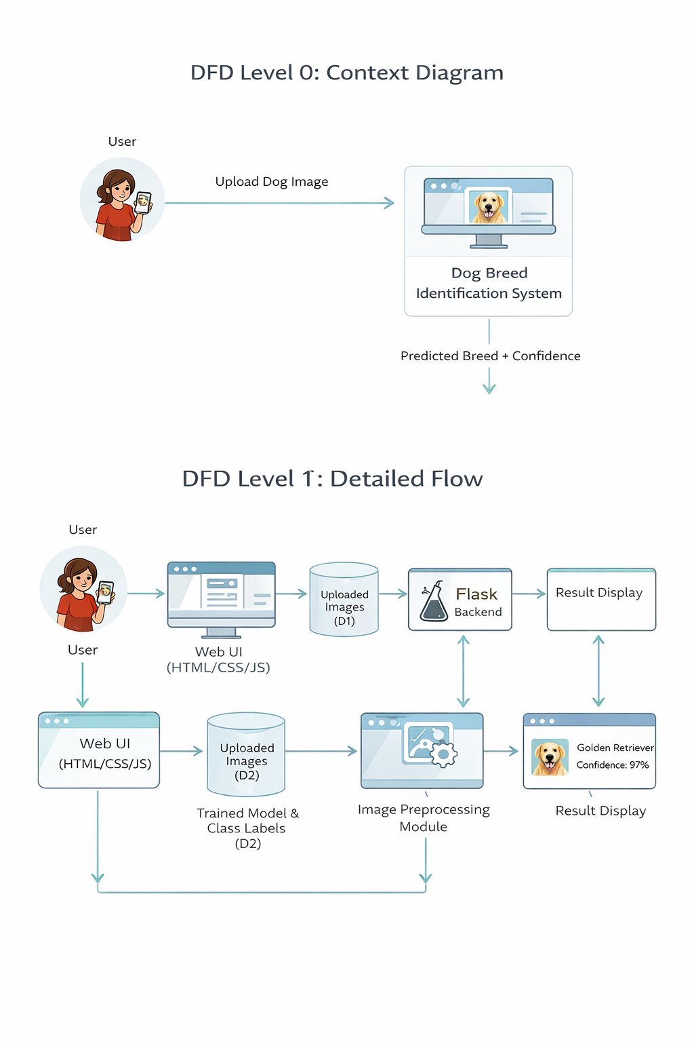

User Stories
User Type | Functional Requirement (Epic) | User Story No. | User Story / Task | Acceptance Criteria | Priority | Release
Customer (Web) | Image Upload | USN-1 | As a user, I can upload a dog image from my device to identify its breed. | Image is uploaded and previewed successfully | High | Sprint-1
Customer (Web) | Breed Prediction | USN-2 | As a user, I can get the predicted dog breed after uploading an image. | Breed name is displayed correctly | High | Sprint-1
Customer (Web) | Confidence Display | USN-3 | As a user, I can view the confidence score of the prediction. | Confidence score is shown on result page | Medium | Sprint-1
Customer (Web) | Error Handling | USN-4 | As a user, I get an error message for invalid image formats. | Error message shown for unsupported files | Medium | Sprint-1
Customer (Web) | Re-upload Image | USN-5 | As a user, I can upload another image for a new prediction. | User can upload new image without refreshing the entire app | Low | Sprint-2
Administrator | Model Management (Optional) | USN-6 | As an admin, I can update the ML model with a new trained version. | System loads new model without breaking the app | Low | Sprint-2

